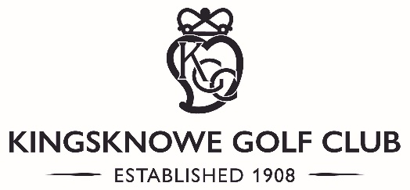
LADIES INTER CLUB TOURNAMENT 2022
 | Wednesday 4th May | Friday 6th May | Saturday 7th May  SEMI FINALS | Saturday 7th May  FINAL
4.00 &  4.10 | KINGSKNOWE | 4.00  Kingsknowe 12&11 | 09.00  Turnhouse 2&1 | 2.00 & 2.10  Turnhouse 8&7 | WINNERS  2022
 | ROYAL MUSSELBURGH
4.20 &  4.30 | TURNHOUSE | 4.10  Turnhouse 1up
 | BABERTON
4.40 &  4.50 | MERCHANTS | 4.20  Merchants 5&3 | 09.10  Newbattle 2up
 | GLENCORSE
5.00 &  5.10 | NEWBATTLE | 4.30  Newbattle 4&3
 | RATHO PARK
 | Thursday 5th May
4.00 &  4.10 | MURRAYFIELD | 4.40  Murrayfield 10&9 | 09.20  Broomieknowe 4&2 | 2.20 & 2.30  Mortonhall 2&1
 | MUSSELBURGH
4.20 &  4.30 | BROOMIEKNOWE | 4.50  Broomieknowe 5&4
 | CRAIGMILLAR PARK
4.40 &  4.50 | MORTONHALL | 5.00  Mortonhall 4&2 | 09.40  Mortonhall 6&5
 | DALMAHOY
5.00 &  5.10 | PRESTONFIELD | 5.10  Liberton 4&1
 | LIBERTON

